Name of the Student: G. Manasa | Academic Year: 2025-26
Student Registration Number: 241U1R3007 | Year & Term: II & II
Study Level: UG | Class & Section: CSE(DS)-2A
Name of the Course: FOUNDATION OF DATA SCIENCE | Name of the Instructor: Mr. Pranay Vemula, Assistant Professor, CSE.
Name of the Assessment: Reflective Lab Journal 9 | Date of Submission: 16-12-2025

Reflective Lab Journal 9

Marketing Campaign Performance & Sales Analysis

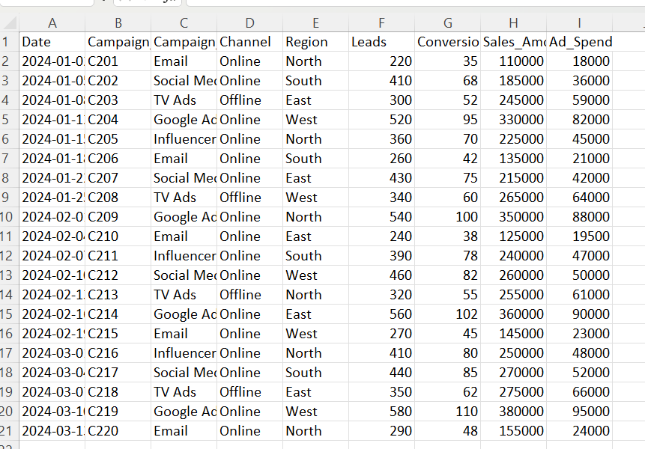

1. Compare sales amount for different campaign types.

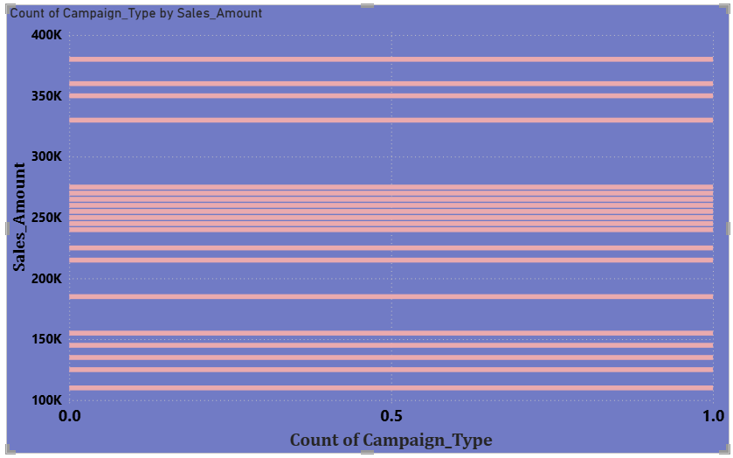

2. Show the number of leads generated in each region.

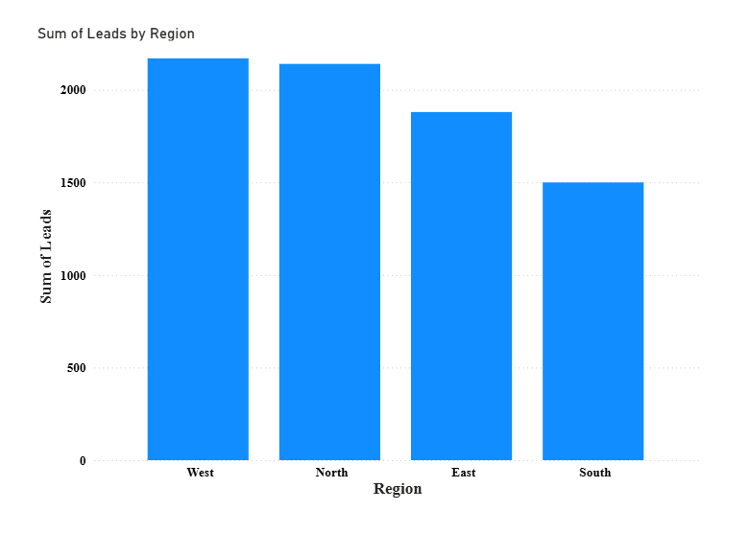

3.Display the sales trend over time.

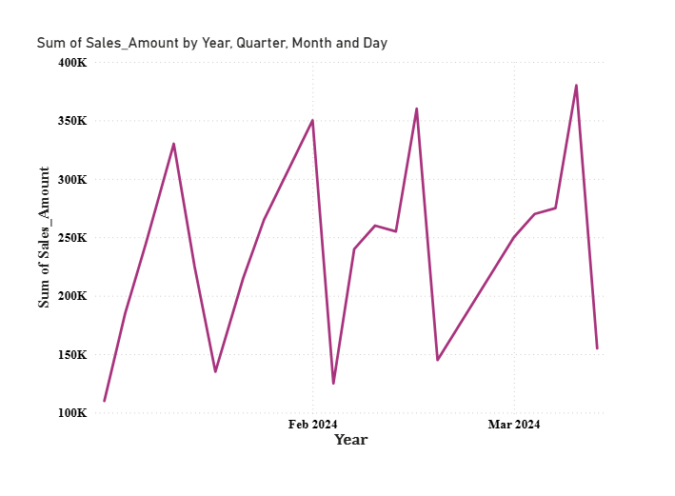

4.Show sales distribution between online and offline channels.

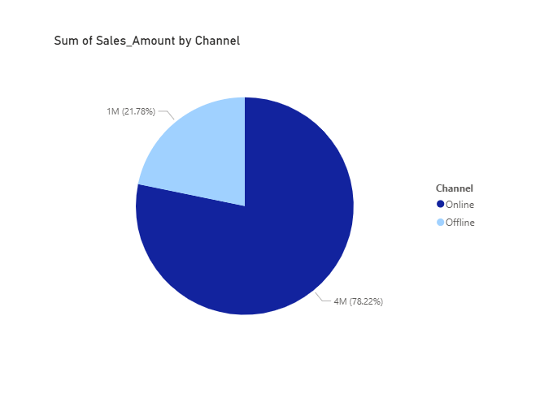

5.Compare leads and conversions for each campaign type.
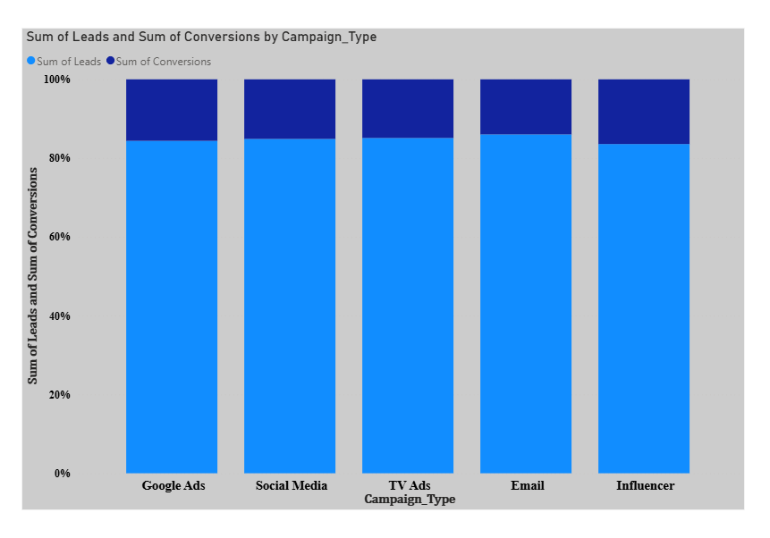

6.Display the top 5 campaigns based on sales amount.
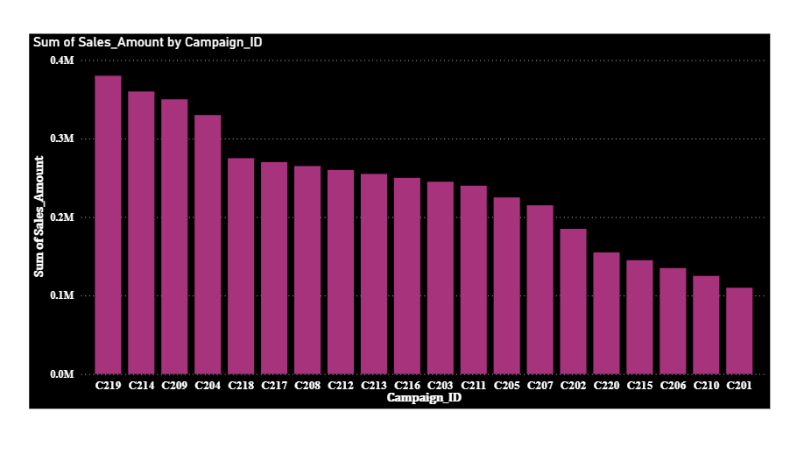

7. Show campaign-wise performance details including sales and ad spend.

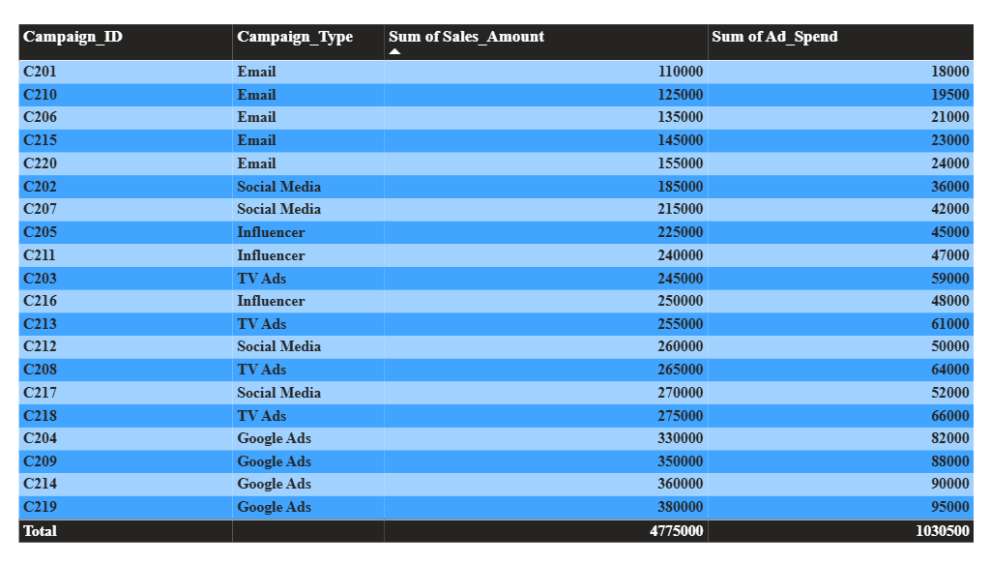

8. Compare ad spend for different campaign types.

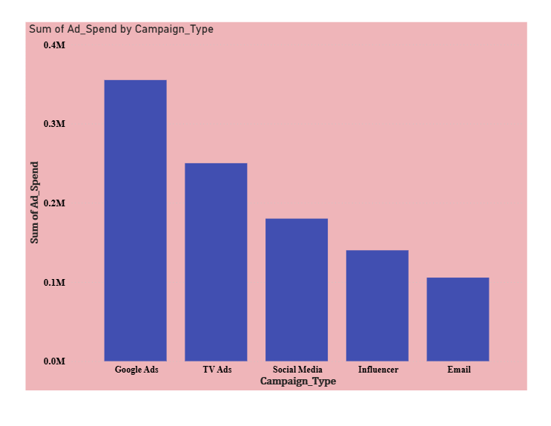

9. Display the cumulative sales trend over time.

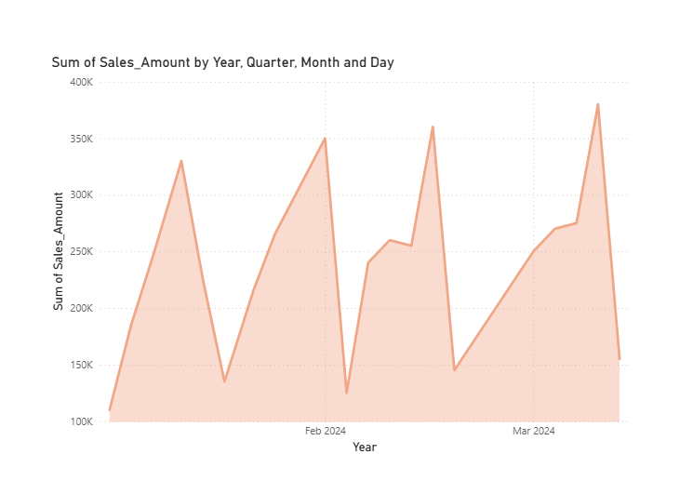

10. Show conversion rate for each campaign type.
